Name___________________________ Core ___________ Date ___________

Symbiotic Relationships Worksheet Review

Read each scenario below. Decide what ecological relationship is occurring and write it next to the scenario. You can abbreviate.
Mutualism = both benefit
Commensalism = One benefits and other is unaffected
Parasitism = One benefits and the other is harmed
Predator = One animal preys on another

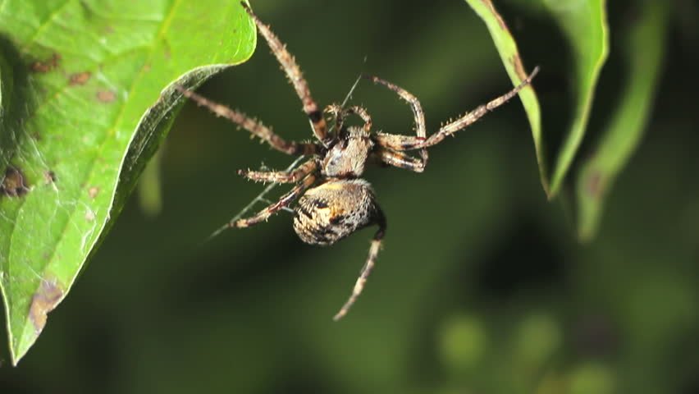
1. ________ A tangle web spider tends to spend much of its time in the trees where is has access to many insects for food. Its leg formation and ability to create elaborate webs means it has a great advantage in the trees and off the ground. A jogger ran into a tangle web spider as she ran by some low hanging branches. The web spider traveled onto the human until it was brushed off near a new grouping of trees with more potential for food.

2. _________ A raccoon scavenges for any food that it can find. This racoon comes across a dead rotting animal. It consumes some tapeworm eggs from the raw meat. The eggs hatch and attach to the racoon’s stomach. As the racoon feeds, the tapeworm steals the nutrients which allows it to grow in size.

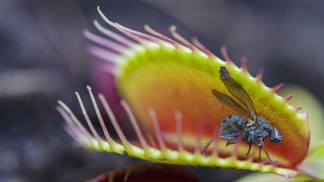
3. _________ A venus flytrap sits patiently, “jaws” open, waiting for an insect to come by. A fly lands on the venus flytrap and drinks some of the nectar that the plant secretes. As the fly moves around the venus flytrap it triggers the venus flytrap to close its jaws. The fly is trapped and is digested.

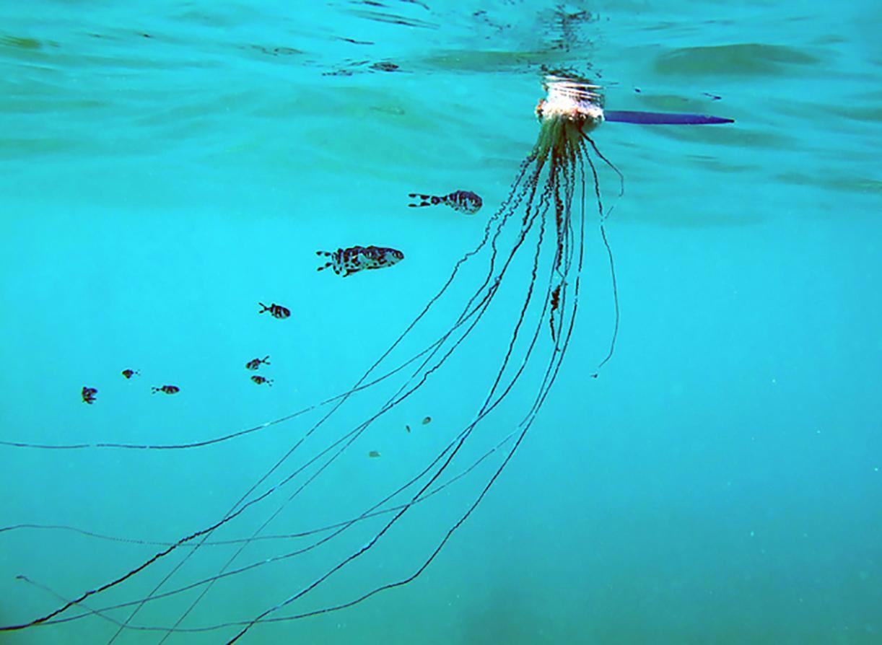
4. _________ Man of War Jellyfish contain many toxic filled stingers called nematocysts. These stingers are able to kill fish and other smaller prey. The Man of War fish, however, is able to swim amongst these stingers without being harmed. This fish is protected from various predators as it travels with the Man of War jellyfish. The jellyfish travels wherever it wants to travel, unhindered by the fish companion.

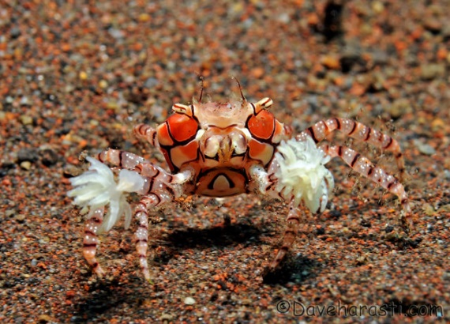
5. _________ Sea Anemones are unable to move around much on their own. However, they still need to obtain food. The boxer crab carries anemones on its claws. It punches at predators with its claws to deliver hard hits as well as a sting from the anemone boxing gloves. It is a great defense mechanism. Crabs are notoriously messy eaters. Any food that is left behind from the crab eating, is scooped up by the anemones on its claws.

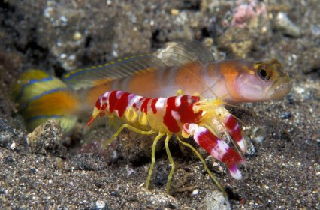
6. _________ Pistol shrimp dig burrows in the sand at the bottom of the ocean. They live there and constantly clean out the sand. This type of shrimp has very poor eyesight and finds it difficult to spot the many predators it has in the ocean. Goby fish also live in the burrow that the shrimp has made. These goby fish watch out for predators and dive into the burrow if they spot something. The shrimp always keeps a tentacle touching the goby so it can react to the danger as well.

7. __________ Pearlfish search around for a safe place to live and rest. It comes across a sea cucumber. The sea cucumber moves around the ocean floor sucking up nutrients from the sand. The pearlfish swims inside the cucumber where it is safe from predators. The sea cucumber is not impacted by the fish in anyway.

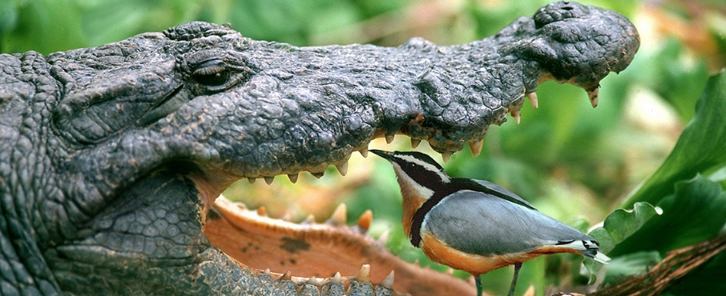
8. __________ The Nile Crocodile interacts with a blackbird called the Plover. The Plover bird acts like a toothpick for the crocodile and helps by removing tiny morsels of food that are stuck between the crocodile's teeth. These food particles are the source of food for the bird.
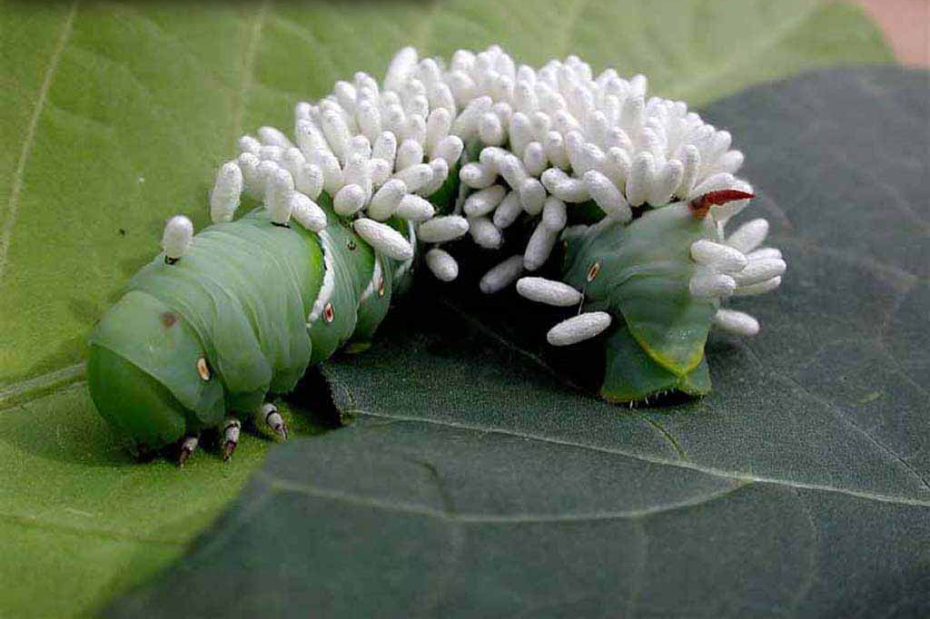
9. __________ Some variety of wasps look for safe places to lay their eggs. Some lay them on the backs of and even inside caterpillars (Catalpa Worms). When the wasp larvae hatch, they are able to consume the caterpillar, using the nutrients to eventually grow into fully formed wasps.

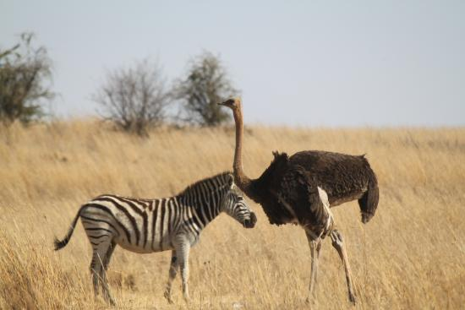
10. __________ Ostrich birds have very poor smell and hearing senses. Zebras have a great sense of smell and hearing. Therefore, the birds commonly travel with zebra herds. The Ostrich, however, have a great sense of sight. This is something the herd of zebras lack. The organisms utilize each others strengths to avoid the many dangers in their ecosystem.

